VR Rehabilitation Game
Technical Design Documentation

Table of Contents
1 Introduction
2 System Architecture Overview
3 Scene Specifications
3.1 Scene 1 – Welcome & User Profile
3.2 Scene 2 – User Preferences
3.3 Scene 3 – Calibration A: IMU Bias / Offset
3.4 Scene 4 – Calibration B: Range of Motion (ROM)
3.5 Scene 5 – Calibration C: Functional Calibration
3.6 Scene 6 – Session Setup
3.7 Scene 7 – Mini-Games
3.8 Scene 8 – Questionnaire
4 Sensor & Tracking Architecture
4.1 Tracking Modes
4.2 Vision Module (Camera-Based)
4.3 IMU Module
4.4 Mode Selection Flag — Per-Game Input
4.5 Compensation Types
5 Feedback System
5.1 Text Feedback
5.2 Audio Feedback
5.3 Visual Feedback — Avatar
5.4 Haptic Feedback
5.5 Feedback Preference Flags
6 ROM Calibration: Detailed Angle Definitions
7 Functional Calibration: Sensor Error Correction
8 Data Storage & Logging
9 Manager Layer Reference

1 Introduction
This document is the official technical design reference for the VR Rehabilitation Game. Its purpose is to give any developer, clinician, or contributor all the information needed to implement or extend any component without ambiguity.
The system is built in Unity using a Core + Additive scene architecture. It interfaces with two sensor modalities: a camera-based vision module and IMU (Inertial Measurement Unit) sensors placed on the upper limb. The game is designed for upper-limb motor rehabilitation. (THIS ARCHITECTURE MOST LIKELY WILL CHANGE ONCE INSTALLING LABO EXTENSION)

2 System Architecture Overview
The application uses a Core + Additive scene workflow in Unity 6.2(6000.2.8f1). One persistent Core Scene is always loaded and contains all global managers and the XR Rig. Mini-game environments are loaded and unloaded additively on top of this core.

Architecture Summary
Core Scene (always loaded): XR Rig (Meta Camera Rig + Passthrough + Hand Interaction building blocks), all Managers, global UI canvases.
Additive Scenes (loaded/unloaded on demand): Calibration scenes, Session Hub, each Mini-Game.
ScriptableObjects store game definitions: scene name, clinical focus weights, duration, difficulty range.
SessionManager reads ScriptableObjects to build the session schedule.

Session flow — ordered steps:
Sessions proceed through the following ordered steps:
- Welcome & User Profile — select or create patient account
- Settings (optional) — adjust preferences and re-run calibration if needed
- Calibration — IMU offset → ROM → Functional (Not implemented in MVP)
- Session Setup — therapist or patient configures today's session parameters
- Exercise Routine — plays through the prescribed exercise sequence
- Post-Session Questionnaire — per-exercise difficulty and enjoyment ratings
- Difficulty Adaptation & Data Save — kinematics and session metrics persisted

Architecture Summary
Core Scene (always loaded):
  - OVRCameraRig + Passthrough + Hand Interaction Building Blocks
  - All Manager singletons (AppManager, SessionManager, UserManager, SceneLoader, CalibrationManager, UDPReceiver, AvatarDriver, FeedbackManager, ExerciseController, DataLogger, QuestionnaireManager)
  - Global world-space UI canvases
  - UDP Receiver (listens on port 5010, receives IMU MotionPacket JSON (joint angles + compensation flags)

Additive Scenes (loaded/unloaded on demand):
  - Welcome / User Profile
  - Settings / Calibration
  - Session Setup (Hub)
  - Exercise Routine (sequential exercise player)
  - Each Mini-Game environment
  - Post-Session Questionnaire overlay

Configuration:
  - ScriptableObjects store game definitions: scene name, clinical focus weights, exercise type, duration, difficulty range
  - SessionManager reads ScriptableObjects to build the session schedule

3 Scene Specifications
Each scene is specified with its internal contents, required inputs, and produced outputs. All listed fields must be present in the implementation.

How to read the scene specs in Section 3:
Table colour | Meaning
Purple | Scene Contents — every visible UI element and 3D object that must exist in the scene hierarchy
Grey | Runtime Variables — every C# variable the scene reads or writes during execution; includes type and default value
Green | READ — every file or DB source accessed at scene start or during execution; maps source field to runtime variable
Blue | WRITE — every file or DB target written when the scene exits or an action completes; maps runtime variable back to storage

3.1 Scene 1 – Welcome & User Profile
The first scene the user sees. Handles account selection or creation and displays a summary of the patient's rehabilitation progress.
Scene Contents
World-space UI panel — account list (populated from SQLite users table)
Button: Select Existing User → shows scrollable user list
Button: Create New User → reveals text-input form
Text inputs: Username, Affected Side toggle (Left/Right), Dominant Hand toggle, Language dropdown (English), Headset Mode (Seated)
Progress Summary panel (visible after user selected): last session date, total sessions, difficulty trend arrow per exercise type
Confirm/Start button — disabled until valid username entered or existing user selected

Runtime Variables
Variable name | C# type | Description | Default / source
existingUsers | List<UserProfile> | All users loaded from SQLite at scene start | Populated by UserManager.LoadAllUsers()
selectedUserID | int | SQLite primary key of currently selected user | -1 until user taps a profile
newUsername | string | Text-input value for new account creation | Empty string
affectedSide | string | Patient's impaired limb side | "Right" (default)
dominantHand | string | Patient's dominant hand | "Right" (default)
languagePreference | string | UI language code | "en"
headsetMode | string | Seated or standing mode | "Seated"
progressSummary | SessionSummary | Last session date, total count, difficulty trends | Null until user selected; loaded by SessionManager
isNewUser | bool | Tracks whether create-new or select-existing flow | false

File I/O
READ — data loaded into memory at scene start
File | JSON key / SQL column | C# type | Runtime variable | Notes
users (SQLite) | user_id | int | existingUsers[n].userID | Loaded on scene Awake()
users (SQLite) | username | string | existingUsers[n].username | Loaded on scene Awake()
users (SQLite) | affected_side | string | existingUsers[n].affectedSide | Loaded on scene Awake()
users (SQLite) | dominant_hand | string | existingUsers[n].dominantHand | Loaded on scene Awake()
users (SQLite) | language | string | existingUsers[n].language | Loaded on scene Awake()
sessions (SQLite) | start_time (MAX) | string | progressSummary.lastSessionDate | Queried per selected user
sessions (SQLite) | COUNT(session_id) | int | progressSummary.totalSessions | Queried per selected user
system_defaults.json | default_language | string | languagePreference | Fallback if no prior profile
system_defaults.json | default_headset_mode | string | headsetMode | Fallback if no prior profile
WRITE — data persisted when scene exits or action completes
File | JSON key / SQL column | C# type | Runtime variable | Notes
users (SQLite) | user_id | int | UserManager.CurrentUserID | INSERT on new user; auto-increment PK
users (SQLite) | username | string | newUsername | INSERT on new user only
users (SQLite) | affected_side | string | affectedSide | INSERT on new user only
users (SQLite) | dominant_hand | string | dominantHand | INSERT on new user only
users (SQLite) | language | string | languagePreference | INSERT on new user only
users (SQLite) | headset_mode | string | headsetMode | INSERT on new user only

3.2 Scene 2 – User Preferences
Consolidates patient preferences and calibration re-launch buttons. Accessible from the main menu at any time; does not interrupt an active session.
Scene Contents
Preference panel — pain slider (0–10), feedback intensity (Low/Med/High), Audio/Haptic/Text toggles, Tracking mode label (IMU), Speed modifier buttons (0.5×/1×/1.5×)
Calibration access panel — three buttons: Re-run IMU Bias, Re-run ROM, Re-run Functional; each shows red warning badge if corresponding calibration is marked invalid
Avatar visibility label — always-on notice (cannot be toggled)
Save & Continue button — writes preferences and navigates to Session Setup

Runtime Variables
Variable name | C# type | Description | Default / source
painLevel | int | Self-reported pain today (0–10) | Last saved value or 0
feedbackIntensity | string | Low / Medium / High | "Medium"
audio_On | bool | TTS audio feedback enabled | true
haptic_On | bool | Controller vibration feedback enabled | true
text_On | bool | World-space text panel enabled | true
trackingMode | string | Input modality — fixed to IMU in current build | "IMU" (read-only label)
speedModifier | float | Multiplier applied to all exercise speed thresholds | 1.0f
imuCalibValid | bool | Whether IMU bias calibration is current | Read from calibration.json
romCalibValid | bool | Whether ROM calibration is current | Read from calibration.json
funcCalibValid | bool | Whether functional calibration is current | Read from calibration.json

File I/O
READ — data loaded into memory at scene start
File | JSON key / SQL column | C# type | Runtime variable | Notes
user_preferences (SQLite) | pain_level | int | painLevel | Last session value; default 0
user_preferences (SQLite) | feedback_intensity | string | feedbackIntensity | Last session value
user_preferences (SQLite) | audio_on | bool | audioFeedbackOn | Last session value
user_preferences (SQLite) | haptic_on | bool | hapticFeedbackOn | Last session value
user_preferences (SQLite) | text_on | bool | textFeedbackOn | Last session value
user_preferences (SQLite) | speed_modifier | float | speedModifier | Last session value
calibration.json | imu_bias.valid | bool | imuCalibValid | Badge shown if false
calibration.json | rom.valid | bool | romCalibValid | Badge shown if false
calibration.json | functional.valid | bool | funcCalibValid | Badge shown if false
WRITE — data persisted when scene exits or action completes
File | JSON key / SQL column | C# type | Runtime variable | Notes
user_preferences (SQLite) | session_id | int | SessionManager.CurrentSessionID | FK — set at session creation
user_preferences (SQLite) | pain_level | int | painLevel | Written on Save & Continue
user_preferences (SQLite) | feedback_intensity | string | feedbackIntensity | Written on Save & Continue
user_preferences (SQLite) | audio_on | bool | audioFeedbackOn | Written on Save & Continue
user_preferences (SQLite) | haptic_on | bool | hapticFeedbackOn | Written on Save & Continue
user_preferences (SQLite) | tracking_mode | string | trackingMode | Written on Save & Continue
user_preferences (SQLite) | speed_modifier | float | speedModifier | Written on Save & Continue

3.3 Scene 3 – Calibration A: IMU Bone Offset
Guided procedure for IMU bias calibration. Participant is to hold a neutral pose for 5 seconds. The scene instructs the user to assume required static poses while the external IMU processing pipeline estimates sensor offsets. No calibration computation is performed within the VR application.
Mandatory at the beginning of every use, once the imus are detected or asked the user whether imus are to be connected if they haven't already.

UI Elements
• Help button: Displays correct IMU placement diagrams (upper arm, forearm, etc.), orientation guidance, and attachment instructions.
• Sensor status panel: Shows each required IMU with:
Connection state (Connected / Not Connected)
Activity state (Streaming / Not streaming)
• Instruction panel: Displays current task instructions.
• Countdown timer: Default 5 seconds (configurable 5–10 s).
• Start button: Enabled only when all required IMUs are connected and active.

Steps
1. User enters the scene; the application verifies IMU connectivity.
2. If any sensor is missing or inactive, calibration cannot proceed.
3. User may open the Help panel to confirm correct IMU placement.
4. Application instructs: 'Hold your arm still at your side in the neutral position. Do not move for 5 seconds.'
5. User presses Start → countdown begins.
6. During the countdown, the external IMU system collects stationary samples.
7. The external pipeline computes bias/offset values from these samples.
8. Upon completion, the VR application receives a confirmation message indicating calibration success or failure.
9. Calibration status is saved locally.

Runtime Variables
Variable name | C# type | Description | Default / source
imuSensorIDs | string[] | Sensor IDs expected for this patient | Loaded from calibration.json
sensorConnected | Dictionary<string,bool> | Connection state per sensor ID | Polled via UDP on Awake()
sensorStreaming | Dictionary<string,bool> | Stream-active state per sensor ID | Updated on each UDP heartbeat
countdownDuration | int | Calibration hold duration in seconds | 5 (configurable 5–10 in settings.json)
calibrationStarted | bool | True once user taps Start | false
calibrationSuccess | bool | Result received from Raspberry Pi confirmation | false until signal received
allSensorsReady | bool | True when all IDs are Connected AND Streaming | Derived; gates Start button

File I/O
READ — data loaded into memory at scene start
File | JSON key / SQL column | C# type | Runtime variable | Notes
calibration.json | sensor_ids | string[] | imuSensorIDs | Which IMUs are expected
settings.json | prep_countdown_seconds | int | countdownDuration | Default 5; range 3–5
UDP (port 5010) | heartbeat packet | JSON | sensorConnected / sensorStreaming | Polled every 500 ms on Awake()
WRITE — data persisted when scene exits or action completes
File | JSON key / SQL column | C# type | Runtime variable | Notes
calibration.json | imu_bone_offset.valid | bool | calibrationSuccess | true on Pi confirmation; false on timeout
calibration.json | imu_bone_offset.timestamp | string | DateTime.UtcNow.ToString() | ISO-8601 timestamp on success
calibration_imu (SQLite) | user_id | int | UserManager.CurrentUserID | FK
calibration_imu (SQLite) | sensor_id | string | imuSensorIDs[n] | One row per sensor
calibration_imu (SQLite) | timestamp | string | calibration timestamp | Matches calibration.json value

3.4 Scene 4 – Calibration B: Range of Motion (ROM)
Guides the user through a set of ROM tests to determine personal minimum and maximum joint angles. This step is performed only when required (e.g., first use is a must, or when recalibration is requested in case the user abilities have changed). Otherwise, previously stored ROM values are reused.

ROM Calibration Requirement
The system checks whether ROM calibration is needed based on session configuration or stored calibration status.

Conditions that trigger ROM calibration:
• First session for the user
• Clinician/user requests recalibration
• Previous calibration missing or invalid

If calibration is not required, the scene is skipped and stored ROM values are used.

Scene Contents
Phase 1 — Instruction: exercise name label, 3D avatar demo loop, TTS instruction auto-play, Replay Audio button, Start/Auto-countdown button
Phase 2 — Prep Countdown: large numerals 5…1, spoken countdown audio, video demo available
Phase 3 — Recording Window: 10-second countdown timer, avatar mirrors live IMU input, real-time angle progress bar (min–max arc)
Phase 4 — Stop & Transition: 'Done' confirmation flash (1 s), 1.5 s pause, auto-advance to next joint or end scene
Retry prompt panel — appears on first failure: 'Let's try that again'
Skip/Fail notice — shown silently to clinician log when joint fails both attempts
Five joints run in fixed order: Shoulder Rotation → Shoulder Abduction → Shoulder Flexion → Elbow Flexion → Wrist Pronation

ROM Tests Performed (in order)
1. Shoulder Rotation — normal range: −90° to +90°
2. Shoulder Abduction — normal range: 0° to +90°
3. Shoulder Flexion — normal range: 0° to +90°
4. Elbow Flexion — normal range: 0° to +180°
5. Wrist Pronation — normal range: −90° to +90°

Each test: guided movement instructions + real-time angle progress bar on screen.
System records running minimum and maximum joint angles from both Quest-based tracking and IMU data.
These measurements are compared, and user-specific ROM limits are saved locally.

Runtime Variables
Variable name | C# type | Description | Default / source
currentJointIndex | int | 0-based index into joint sequence (0–4) | 0 on scene start
currentPhase | RomPhase (enum) | Instruction / PrepCountdown / Recording / Transition | RomPhase.Instruction
runningMin | float | Running minimum angle captured this recording window | float.PositiveInfinity
runningMax | float | Running maximum angle captured this recording window | float.NegativeInfinity
isRecording | bool | True during Phase 3 — UDP packets processed | false
retryCount | int | Retry attempts for current joint (max 1) | 0
recordingWindowSecs | int | Duration of Phase 3 window | 10 (configurable 5–15)
minRangeDeg | float | Failure threshold: runningMax − runningMin must exceed | 5.0f (configurable 1–15)
packetsReceived | int | UDP packets received for current joint this window | 0; reset each phase start
jointSequence | string[] | Fixed order of joint keys | shoulder_rotation, shoulder_abduction, shoulder_flexion, elbow_flexion, wrist_pronation
romProfile | ROMProfile | Accumulated min/max results for all five joints | Built up as joints complete
currentLiveAngle | float | Latest angle_deg from UDP for current joint | Updated each Update() tick

File I/O
READ — data loaded into memory at scene start
File | JSON key / SQL column | C# type | Runtime variable | Notes
settings.json | prep_countdown_seconds | int | countdownDuration | Default 5
settings.json | recording_window_seconds | int | recordingWindowSecs | Default 10
settings.json | min_range_deg | float | minRangeDeg | Default 5.0°
settings.json | max_retries_per_joint | int | max 1 retry | Default 1
calibration.json | imu_bias.valid | bool | — (prerequisite check only) | Scene blocked if false
UDP (port 5010) | angle_deg (per joint) | float | currentLiveAngle / runningMin/Max | Phase 3 only; other joints ignored
WRITE — data persisted when scene exits or action completes
File | JSON key / SQL column | C# type | Runtime variable | Notes
calibration.json | rom.[joint].min | float | runningMin | Written after valid Phase 4 per joint
calibration.json | rom.[joint].max | float | runningMax | Written after valid Phase 4 per joint
calibration.json | rom.[joint].complete | bool | true / false | false if both retries failed
calibration.json | rom.valid | bool | true when all 5 joints complete | Written on scene exit
calibration.json | rom.calibrated_at | string | DateTime.UtcNow.ToString() | ISO-8601 on scene exit
calibration_rom (SQLite) | joint | string | jointSequence[currentJointIndex] | One row per joint
calibration_rom (SQLite) | rom_min | float | runningMin | One row per joint
calibration_rom (SQLite) | rom_max | float | runningMax | One row per joint
calibration_rom (SQLite) | timestamp | string | calibration timestamp | Same as calibration.json value
sensor_health.json | type | string | "rom_calibration_failed" | Only on double-fail joints
sensor_health.json | joint | string | failed joint key | Only on double-fail joints
sensor_health.json | final_range_deg | float | runningMax − runningMin | Actual range measured
sensor_health.json | packets_received | int | packetsReceived | For diagnostics

FAILURE LOGIC: A recording fails if (runningMax − runningMin) < minRangeDeg OR packetsReceived = 0. One retry is allowed. On second failure: mark rom.[joint].complete = false, append to sensor_health.json, advance to next joint.

3.4.1 – Trigger conditions
The calibration runs when any of the following are true:
- First session for the current user
- Clinician or user explicitly requested recalibration
- Previous calibration is missing or marked invalid in calibration.json

Otherwise the scene is skipped and previously stored ROM values are reused.

3.4.2 – Prerequisites
- User profile loaded ( UserManager has CurrentUserID set)
- User preferences loaded
- IMU bone offset calibration complete ( IMU_bias written to calibration.json)
All required IMUs connected and streaming on UDP port

3.5 Per-joint Phase sequence
Each joint runs through four sequential phases. Total duration per joint is approximately 15 seconds plus 1-2 second transition to the next joint.

Phase 1 – Instruction Phase

Presents the movement the user must perform.

Display monitor shows:
- Joint-specific instruction text (e.g., “Raise your arm out to your side as far as you can, then bring it back down to your side”)
- 3D avatar demo looping the target movement (same humanoid rig used during gameplay)
- “Replay audio” button (speaker icon) – user may tap to replay the audio instruction
- “start” button – user taps to begin the prep countdown ( or automatic countdown which is preferred)

Audio:
- Pre-generated TTS clips plays once automatically when this phase begins
- Clip does NOT auto-repeat; user must tap Replay to hear again

Exit condition:
- User taps “start” which advances to Phase 2 ( countdown)

Phase 2 – prep countdown
Five-second “get ready” period before recording begins.

Display monitor shows:
- Large countdown numerals: 5..4..3..2..1
- Instruction text remain visible ( smaller, secondary position)
- Avatar demo continue looping

Audio:
- Spoken numbers play at each second tick: “5, 4, 3, 2, 1, GO”
- The “GO” audio doubles as the recording-start cue

Timing: Default: 5 seconds. Configurable (3-5s range) via seatings JSON.

Phase 3 – Recording Window
User performs the movement while the system records the min and max joint angle.

Display monitor shows:
- Large visual timer counting down from 10 seconds
- Avatar mirrors the user’s live movement, driven by the UDP joint angle stream

Audio:
- Silent during the 10 seconds
- Recording-start cue: the “GO” clip from phase 2

Timing: default 10 seconds. Configurable (5-15s range) Via settings.

Recording logic:
- At phase start: running_min= +infinity, running_max= -infinity
- On every UDP packet where packet joint matches the current test joint: update running_min and running_max
- UDP packets for other joints are ignored

Phase 4 – Stop and transition

Display monitor shows:
- Brief “Done” confirmation on screen (1 second)
- Measured range is NOT shown to the user (design decision: clinician reviews values post-session)

Audio:
- Stop cue: audio beep + spoken “Done” played in sequence

Data handling:
- Evaluate recording validity
- If valid: persist running_min and running_max to calibration.json under the joint’s entry
- If invalid: trigger retry logic

Transition:
- 1-2 second pause
- Auto-advanced to phase 1 of the next joint, or end the scene if this was the final joint (wrist pronation)

3.6 Data flow and storage

Input:
- Live UDP stream from Raspberry pi on port (50 Hz)
- Each packet carries a single joint’s calibrated angle (post bias correction + functional correction)

Runtime state (per joint)
float runningMin = float.PositiveInfinity;
float runningMax = float.NegativeInfinity;
bool isRecording = false;
string currentTestJoint = null; // e.g. "shoulder_abduction"
int retryCount = 0;

3.7 Retry and failure handling

Failure detection criteria
A recording is flagged as failed if ANY of the following conditions are true at the end of phase 3 (recording window):
1. Running_max – Running_min < 5°. Meaning user did not move through a meaningful range
2. Running_min is still +infinity or Running_max is still –infinity ---- no UDP packets were received for this joint during the window

Retry behaviour
- On first failure: display “Let’s try that again” on monitor, play spoken “Let’s try again” audio, increment retryCount to 1, return to phase 1 (Instruction) for the same joint
- Maximum 1 auto-retry per joint; this prevents infinite loops if a sensor is broken or the patient cannot perform the movement
- If the retry also fails: mark the joint as complete==false in calibration.json, log a sensor_health event, advance to the next joint without blocking the scene

Sensor health log entry
When a joint fails both attempts, append an entry to the active session’s sensor_health.json:

{
"timestamp_ms": 1745136542100,
"type": "rom_calibration_failed",
"joint": "wrist_pronation",
"final_range_deg": 2.1, // actual range measured (if any)
"packets_received": 12, // UDP packet count during window
"attempts": 2
}

3.8 Audio assets
All audio is generated via TTS at development time and shipped as .wav files. No runtime TTS synthesis is required.

File layout
Assets/Audio/Calibration/en/
├── numbers/
│ ├── 5.wav
│ ├── 4.wav
│ ├── 3.wav
│ ├── 2.wav
│ ├── 1.wav
│ └── go.wav
├── cues/
│ ├── stop_beep.wav
│ ├── done.wav
│ └── retry_prompt.wav
└── instructions/
├── shoulder_abduction.wav
├── shoulder_flexion.wav
├── elbow_flexion.wav
├── shoulder_rotation.wav
└── wrist_pronation.wav

Manager contract
public class CalibrationAudioManager {
public void PlayInstruction(string jointKey); // "shoulder_abduction" etc.
public void PlayCountdownNumber(int number); // 1..5
public void PlayGoCue();
public void PlayStopCue(); // beep + spoken "Done!"
public void PlayRetryPrompt();
public void ReplayInstruction(); // for the Replay button
}

3.9 Manager integration

ROM calibration is orchestrated by calibrationManager. This section specifies the ROM-specific additions.

CalibrationManager – ROM methods
public class CalibrationManager {
// ... existing members ...

public void StartRomCalibration();
public void OnUdpPacketReceived(UdpPacket packet); // subscribed at phase 3 start
public ROMProfile GetRomProfile();
public bool IsRomCalibrationRequired(); // evaluates trigger conditions
}
Data structures
public enum RomPhase { Instruction, PrepCountdown, Recording, Transition }

public class RomJointEntry {
public string Joint;
public float Min;
public float Max;
public bool Complete;
public int Retries;
public DateTime RecordedAt;
}

public class ROMProfile {
public Dictionary<string, RomJointEntry> Entries;
public DateTime CalibratedAt;
}

Event hooks

- OnRomCalibrationStarted – fired when the scene loads
- OnJointTestStarted(string joint) -- fired at phase 1 for each joint
- OnJointTestCompleted(RomJointEntry entry) -- fired after phase 4 regardless of success
- OnRomCalibrationCompleted(RomProfile profile) -- fired after final joint; SessionManager listens to advance

3.6 Configurable settings
These values should live in a settings JSON loaded at scene start. Defaults are shown.

Setting | Default | Range | Notes
prep_countdown_seconds | 5 | 3–5 | Matches IMU bone offset calibration countdown for consistency
recording_window_seconds | 10 | 5–15 | Length of Phase 3 (time the user has to perform the movement)
min_range_deg | 5.0 | 1–15 | Failure threshold: max − min must exceed this
max_retries_per_joint | 1 | 0–2 | 0 = no retries; 2+ risks infinite loops if sensor broken
transition_pause_seconds | 1.5 | 1–3 | Pause between joints (after Phase 4, before next Phase 1)

3.7 Acceptance criteria

The Rom calibration scene is considered implementation-complete when all of the following are demonstrably true:
- Scene loads when IsRomCalibrationRequired() returns true; scene is skipped otherwise
- All five joints run in order
- Each joint executes the four phases with correct timing
- Avatar demo plays and loops correctly in phase 1
- Avatar mirror follows live UDP input in phase 3
- Spoken countdown and stop cue audio play at correct moments
- Failed recordings trigger exaclty on retry (no infinite loops)
- Joints failing both attempts are marked complete:false and logged to sensor_health.json

3.5 Scene 5 – Calibration C: Functional Calibration
Systematic sensor alignment (functional calibration) is performed by the external IMU processing system during the ROM exercises. It uses the recorded movements to estimate placement-related errors. This step does not occur as a separate procedure within the VR application.

Procedure
The user performs a known reference movement (e.g., arm fully extended horizontally).
The software reads the IMU-reported angle for that movement.
Correction factor = expected angle − reported angle.
Correction factors are applied as additive offsets to all subsequent angle readings.
There is NO confidence score output. There is NO VR headset interaction during this step.

Step | Reference Movement | Expected Angle | Correction Factor Stored
1 | Arm extended horizontally forward (shoulder flexion) | 90° | correction_shoulder_flexion
2 | Arm extended laterally (shoulder abduction) | 90° | correction_shoulder_abduction
3 | Forearm in neutral pronation position | 0° | correction_wrist_pronation
4 | Elbow fully extended at side | 0° | correction_elbow_flexion
5 | Arm in neutral rotation | 0° | correction_shoulder_rotation

Correction Formula
corrected_angle = raw_imu_angle − bias_offset − correction_factor

Applied in real-time by the Raspberry Pi before sending data to Unity.
Stored per user, per sensor_id, with timestamp in JSON.
If any correction factor exceeds ±30°, a warning is shown prompting the user to re-attach the sensor.

3.6 Scene 6 – Session Setup
The Session Hub where the user configures the upcoming session. Creates the sessions row in SQLite and writes session_config.json which all subsequent scenes read.

Scene Contents
Total session time slider — 5 to 60 minutes, integer steps
Warm-up time slider — 1 to 10 minutes; validation: must be < total session time
Exercise toggle list — one toggle per ExerciseDefinition ScriptableObject; minimum 1 must remain enabled
Goal weight panel — three sliders: Speed / ROM / Accuracy; live sum display; locked at 100 total
Affected side override — Left / Right / Bilateral radio; defaults to UserProfile value
Summary preview — calculated active exercise time after warm-up, exercise count
Start Session button — disabled while goal weights ≠ 100 or no exercises enabled

Runtime Variables
Variable name | C# type | Description | Default / source
totalSessionTime | int | Total session duration in minutes | 20
warmupTime | int | Warm-up duration in minutes | 3
enabledExercises | List<string> | Names of enabled ExerciseDefinition assets | All 11 enabled by default
goalWeightSpeed | int | Speed goal weight (0–100) | 33
goalWeightROM | int | ROM goal weight (0–100) | 34
goalWeightAccuracy | int | Accuracy goal weight (0–100) | 33
affectedSideOverride | string | Left / Right / Bilateral for this session | From UserProfile.affectedSide
sessionConfig | SessionConfig | Assembled config object passed to SessionManager | Built on Start Session tap

File I/O
READ — data loaded into memory at scene start
File | JSON key / SQL column | C# type | Runtime variable | Notes
users (SQLite) | affected_side | string | affectedSideOverride | Pre-fills the override selector
user_preferences (SQLite) | speed_modifier | float | — (passed to ExerciseController) | Loaded by SessionManager
calibration.json | rom.[joint].max | float | ROMProfile (all 5 joints) | Used to compute exercise target thresholds
ExerciseDefinitions | ScriptableObject[] | SO asset | enabledExercises list | Loaded from Resources folder
settings.json | target_success_rate_upper | float | — (passed to ExerciseController) | Not displayed; loaded by SessionManager
WRITE — data persisted when scene exits or action completes
File | JSON key / SQL column | C# type | Runtime variable | Notes
sessions (SQLite) | session_id | int | SessionManager.CurrentSessionID | INSERT; auto-increment PK
sessions (SQLite) | user_id | int | UserManager.CurrentUserID | FK
sessions (SQLite) | start_time | string | DateTime.UtcNow.ToString() | Set on Start Session tap
sessions (SQLite) | total_time_s | int | totalSessionTime × 60
sessions (SQLite) | warmup_time_s | int | warmupTime × 60
sessions (SQLite) | goal_weights | string | JSON of speed/rom/accuracy ints | Serialised as JSON string
session_config.json | enabled_exercises | string[] | enabledExercises | Read by ExerciseController at routine start
session_config.json | affected_side | string | affectedSideOverride | Read by ExerciseController
session_config.json | total_time_s | int | totalSessionTime × 60
session_config.json | warmup_time_s | int | warmupTime × 60

3.7 Scene 7 – Exercise Routine
Each mini-game is an additively-loaded Unity scene containing the environment, targets, and a GameController.
Scene 7 — Inputs & Outputs
INPUT: SessionConfig. ROMProfile. IMU calibration params + correction factors. Live angle from Raspberry pi via UDP.

OUTPUT — High-frequency events (logged ~50 Hz to SQLite events table):
posture_flag, feedback_issued, feedback_corrected, correction_latency_ms, error_type, timestamp_ms

OUTPUT — Game result (logged once per game to SQLite game_results table):
completed, score, error_count, min/max angle reached per joint, game_duration_s

Runtime Variables
Variable name | C# type | Description | Default / source
activeGameName | string | ScriptableObject name of the currently loaded game | Set by SessionManager
gameScore | int | Current in-game score | 0 on game start
errorCount | int | Incorrect actions / missed targets | 0 on game start
gameDurationSecs | float | Elapsed active play time | 0f; incremented in Update()
gameCompleted | bool | True when win condition met | false
minAnglePerJoint | Dictionary<string,float> | Min angle reached per joint during game | float.MaxValue per joint
maxAnglePerJoint | Dictionary<string,float> | Max angle reached per joint during game | float.MinValue per joint
NUMBER_of_compensations_detected |  | Total number of feedbacks provided per type of feedback
Number_of_user_correction_after_feedback
User_reaction_time_to_feedback

File I/O
READ — data loaded into memory at scene start
File | JSON key / SQL column | C# type | Runtime variable | Notes
session_config.json | enabled_games | string[] | activeGameName candidate list | Loaded by SessionManager
calibration_rom (SQLite) | rom_max (per joint) | float | ROMProfile.[joint].max | Input mapping normalisation
user_preferences (SQLite) | audio_on / haptic_on | bool | FeedbackManager pref flags | Loaded at Core Scene start
UDP (port 5010) | angle_deg | float | per-game input mapping | 50 Hz during play
UDP (port 5010) | compensation.* | JSON | FeedbackManager trigger | 50 Hz during play
WRITE — data persisted when scene exits or action completes
File | JSON key / SQL column | C# type | Runtime variable | Notes
game_results (SQLite) | session_id | int | SessionManager.CurrentSessionID | FK
game_results (SQLite) | game_name | string | activeGameName | Once at game end
game_results (SQLite) | score | int | gameScore | Once at game end
game_results (SQLite) | error_count | int | errorCount | Once at game end
game_results (SQLite) | completed | bool | gameCompleted | Once at game end
game_results (SQLite) | duration_s | float | gameDurationSecs | Once at game end
events (SQLite) | joint / angle_deg / movement_ok / … | mixed | per-frame MotionPacket fields | ~50 Hz during play

3.8 Scene 8 – Questionnaire
Displayed as an overlay panel after each mini-game ends, before the next game loads.
Scene Fields
Question 1: 'How difficult was this game?' — integer scale 1–10.
Question 2: 'How enjoyable was this game?' — integer scale 1–10.
Both responses are appended to the GameResult for that specific game.

Our Off-the-shelf options:
1-VRQuestionnaireToolkit (Link1)
2- QuestionnaireToolkit (Link2)
3- Immersive Questionnaire Tool (IQT)

Runtime Variables
Variable name | C# type | Description | Default / source
difficultyRating | int | Patient self-report difficulty (1–10) | 5 (neutral default)
enjoymentRating | int | Patient self-report enjoyment (1–10) | 5 (neutral default)
painCheckRating | int? | Optional pain check (0–10); null if not shown | null
showPainCheck | bool | True every 3rd exercise/game | Computed from exercise index % 3
linkedResultID | int | FK to exercise_results or game_results row | Set by QuestionnaireManager before overlay

File I/O
READ — data loaded into memory at scene start
File | JSON key / SQL column | C# type | Runtime variable | Notes
exercise_results (SQLite) | result_id (latest) | int | linkedResultID | Read to know which row to update
sessions (SQLite) | session_id | int | SessionManager.CurrentSessionID | Needed for FK linkage
WRITE — data persisted when scene exits or action completes
File | JSON key / SQL column | C# type | Runtime variable | Notes
exercise_results (SQLite) | difficulty_rating | int | difficultyRating | UPDATE on linked result_id
exercise_results (SQLite) | enjoyment_rating | int | enjoymentRating | UPDATE on linked result_id
exercise_results (SQLite) | pain_check | int? | painCheckRating | UPDATE only if showPainCheck=true

Scene 8 — Inputs & Outputs
INPUT: GameResult object (to link responses to the correct game and session).
OUTPUT: QuestionnaireResult { difficulty_rating: int, enjoyment_rating: int } stored in JSON.

4 Sensor & Tracking Architecture

4.1 IMU Module
IMU sensors attached to the upper arm and forearm stream quaternions data to the Raspberry Pi. The Raspberry Pi performs all motion processing, evaluates the movement quality meaning it detects compensatory movement, including inverse kinematics, joint angle estimation, and compensation detection. The processed results are transmitted to the VR application via UDP messages.
The VR application does not compute joint angles or process raw IMU signals. It only receives processed motion data and uses it to animate the avatar, based on the angles received decides on the game mechanics, and trigger feedback mechanisms.
Upper-body IMU tracking operates independently from the VR headset's positional tracking.

Raspberry Pi Processing Pipeline
Step 1: Raw IMU data from all sensors is streamed to the Raspberry Pi (~50 Hz).
Step 2: Calibration parameters are applied — IMU bias correction and functional calibration offsets.
Step 3: Inverse kinematics are computed to estimate joint angles from the corrected sensor orientations.
Step 4: Joint angle relationships are analyzed to detect compensatory movement patterns
(e.g., trunk lean or shoulder elevation).
Step 5: Computed joint angles and compensation information are packaged into a structured UDP
message and transmitted to the VR application.

All inverse kinematics, filtering, and compensation detection are executed on the Raspberry Pi.
Unity only receives the processed results and uses them for visualization and feedback.

UDP Packet Structure — Raspberry Pi → Unity
Protocol | UDP (connectionless, low latency)
Port | 5010 — must match on both Raspberry Pi and Quest
Transmission rate | ~50 Hz from Raspberry Pi
Packet format | JSON — one MotionPacket per packet (~200–400 bytes)
Transport | Local Wi-Fi; both devices on same subnet

Packet Format (JSON):
Example Packet
{
"joint": "shoulder_flexion",
"angle_deg": 42.3,
"movement_ok": false,
"compensation": {
"detected": true,
"type": "trunk_lean",
"severity": "moderate"
},
"timestamp_ms": 1735200000123
}

Sensor Data Lost Behaviour
State | Behaviour
Gap < 200 ms | Hold last known angle; no alert
4 s >Gap > 2 s | Avatar freezes; yellow warning badge on sensor communication lost; switch to pure quest hand tracking mode
Gap > 5 s | Red 'Sensor Disconnected' overlay; session suspended; gap logged to events table, switch to pure quest hand tracking mode

Field Definitions:
Field | Type | Description
joint | string | Name of the joint movement. Values: shoulder_flexion, shoulder_abduction, shoulder_rotation, elbow_flexion, wrist_pronation
angle_deg | float | Corrected joint angle in degrees, computed from IMU inverse kinematics after applying all calibration parameters
movement_ok | bool | true = movement within acceptable thresholds. false = compensatory movement or incorrect posture detected
compensation.detected | bool | true if a compensatory movement pattern was identified, false otherwise
compensation.type | string | Type of detected compensation. Values: trunk_lean, shoulder_elevation, torso_rotation, elbow_compensation (see Section 4.5)
compensation.severity | string | Severity of the compensation: mild, moderate, or severe
timestamp_ms | long | Unix timestamp in milliseconds generated by the Raspberry Pi when the sample is created

4.2 Mode Selection Flag — Per-Game Input Source
Each game must check tracking_mode at initialization and configure its input accordingly.

Game | Relevant Angle(s) | IMU_CAMERA Source
Flappy Bird | Shoulder Flexion / hand elevation | IMU shoulder flexion angle
Reach Game | Shoulder Abduction + Elbow Flexion | IMU computed angles, both joints
Pirate Ship | Shoulder Rotation + Elbow Flexion | IMU computed angles, both joints

Flappy Bird — Input Mapping
IMU shoulder flexion angle maps linearly to bird vertical position.
Mapping: bird_y = shoulder_flexion / rom_shoulder_flexion_max
Flag passed to GameController: use_imu_angle (bool).

4.3 Compensation Types
Compensatory movements are detected on the Raspberry Pi by analyzing relationships between multiple joint angles and torso orientation simultaneously.
Each compensation type corresponds to a specific movement error pattern. When detected, the Raspberry Pi includes the compensation information in the UDP packet sent to Unity. The VR application uses this information to:
- trigger corrective feedback messages
- highlight the affected body region on the avatar
- optionally trigger haptic feedback
Unity does not compute compensation detection.

Compensation Detection Rules
Type | Detection Logic (Raspberry Pi) | Affected Body Part | Severity Thresholds (the values for the range need to be able to modified)
trunk_lean_forward (torso flexion / hunching forward) | Torso tilts forward beyond threshold while shoulder flexion is increasing | Spine / torso | Mild: 10-20° Moderate: 20-30° Severe: >30°
trunk_lean_backward (torso extension) | Torso tilts backward beyond threshold during shoulder movement | Spine / torso | Mild: 10-20° Moderate: 20-30° Severe: >30°
trunk_lean_lateral | Lateral torso tilt exceeds threshold while shoulder abduction or flexion is increasing | Spine / torso | Mild: 10-20° Moderate: 20-30° Severe: >30°
torso_rotation | Axial torso rotation exceeds threshold while upper limb movement is active | Spine / torso | Mild: 10-20° Moderate: 20-30° Severe: >30°
shoulder_elevation | Shoulder vertical displacement increases beyond neutral baseline during shoulder abduction or flexion or rotation or elbow flexion | Shoulder joint | Mild: 10-20° Moderate: 20-30° Severe: >30°
shoulder_depression | Shoulder vertical displacement increases beyond neutral baseline during shoulder abduction or flexion or rotation or elbow flexion | Shoulder joint | Mild: 10-20° Moderate: 20-30° Severe: >30°
shoulder_protraction | Shoulder horizontal displacement to the front increases beyond neutral baseline during shoulder abduction or flexion or rotation or elbow flexion | Shoulder joint | Mild: 10-20° Moderate: 20-30° Severe: >30°
shoulder_retraction | Shoulder horizontal displacement to the back increases beyond neutral baseline during shoulder abduction or flexion or rotation or elbow flexion | Shoulder joint | Mild: 10-20° Moderate: 20-30° Severe: >30°
elbow_away | Movement of the elbow joint away from the body during shoulder rotation or elbow flexion | Elbow joint | Mild: 10-20° Moderate: 20-30° Severe: >30°

Compensation Message Strings
Each compensation type maps to a corrective feedback message in the patient's selected language. The same message string is used for:
- text feedback panel
- text-to-speech audio feedback
The FeedbackManager in Unity also uses the compensation type to highlight the corresponding avatar body part and optionally trigger haptic cues.

Message Mapping
EN: "You are leaning your body forward — keep your torso upright."
(trunk_lean_forward / hunching)
EN: "You are leaning backward — keep your torso stable."
(trunk_lean_backward)
EN: "You are leaning to the side — keep your torso straight."
(trunk_lean_lateral)
EN: "Your body is rotating — keep your trunk still and move only your arm."
(torso_rotation)
EN: "Your shoulder is rising — keep it relaxed and level."
(shoulder_elevation)
EN: "Your elbow is compensating — keep it stable during the movement."
(elbow_compensation)

Additional languages extend this mapping in the FeedbackManager. The active language is determined by the language field defined in the User Profile (Scene 1).

Important Implementation Note
When a compensation is detected:

1. The Raspberry Pi sets movement_ok = false
2. The compensation type and severity are included in the UDP packet (Pi also sends the message to the haptic modules, communication with haptic modules is the responsibility of the pi and will never be connected to the quest, but will read the user preference file to see if the haptic needs ot be on or not)
3. Unity triggers feedback according to user preferences:
• text feedback
• audio feedback (TTS)
• visual feedback (avatar highlight)

5 Feedback System
The feedback system is the core rehabilitation mechanism. When the Raspberry Pi detects a compensation pattern and sets compensation.detected = true in the UDP packet, the FeedbackManager receives the event and triggers the appropriate feedback channels based on the patient's preferences configured in Scene 2.

Feedback System Overview
Four feedback channels are supported: Text | Audio | Visual (Avatar highlighting) | Haptic
Each channel can be enabled or disabled in User Preferences (Scene 2).
At session start, the FeedbackManager loads all preference flags and initializes the feedback channels.

On each compensation event — if (compensation.detected = true):
if (text_on) → show text panel with compensation message
if (audio_on) → play TTS audio message
if (visual_on) → highlight avatar body segment

Feedback Rate Limiting
Minimum interval between feedback events: 5 seconds.
This cooldown prevents overwhelming the patient during continuous compensatory movement.

Implementation:
if (TimeSinceLastFeedback < cooldown_time)
ignore event

5.1 Text Feedback
Text Feedback Channel
A world-space UI panel in the VR scene displays the compensation message.

Position:
Fixed in the patient's lower field of view. Does not block gameplay elements.

Message source:
compensation.type + user language (which is English)

Display duration:
3 seconds, then fades out.
If a new event occurs while the panel is visible, the message updates immediately.

Severity coloring:
Severity | Text Color
mild | white
moderate | yellow
severe | red

5.2 Audio Feedback
Audio Feedback Channel
Text-to-Speech (TTS) reads the same message string used for the text panel.
Audio output: VR headset speakers.

Audio Trigger Delay
Audio playback begins 1.5 seconds after compensation detection.
Reason: avoids interrupting the patient during short transient errors.
If the compensation resolves before the delay expires, audio is cancelled.

Audio Queue Policy
Only one audio message plays at a time.
If a new compensation event occurs while audio is playing:
the current message stops and the new message replaces it.

Volume Control
Volume is controlled by the feedback_intensity preference.
Values: Low / Medium / High

5.3 Visual Feedback — Avatar
The avatar is a 3D humanoid model rendered in the VR scene that mirrors the patient's arm motion using joint angles received from the IMU UDP stream.
The avatar remains visible during gameplay regardless of the visual feedback preference flag. The visual_on flag controls only the red highlighting feedback, not the avatar motion itself.

Avatar Design
The avatar mirrors the five tracked joint movements in real time using IMU joint angles.

Purpose:
Provide the patient with a continuous external visualization of their arm movement.

Position:
To the side or slightly in front of the patient — visible without blocking gameplay.

Compensation Visualization
If: visual_on = true AND compensation.detected = true
→ The corresponding avatar body segment is highlighted.

When movement_ok = true:
→ All avatar segments return to their default material color.

Severity highlighting:
Severity | Highlight Style
mild | light red
moderate | solid red
severe | flashing red

Avatar Body Segment Mapping:
Compensation Type | Highlighted Body Part
trunk_lean_forward | Spine / torso
shoulder_elevation | Shoulder joint
elbow_compensation | Elbow joint
Shoulder_protraction | Shoulder joint
torso_rotation | Spine / torso
Trunk_lean_backward | Spine/torso
Trunk_lean_lateral | Spine/torso

Avatar Implementation Notes
The avatar is driven by IMU joint angles from the UDP stream — not by Quest hand tracking.
Joint angles must be mapped to avatar bone rotations according to the XR rig coordinate system.
Body part highlighting is implemented through material color changes on the affected mesh segment.
The avatar rig must contain separate materials for: torso, upper arm, forearm, wrist, hand.

5.5 Feedback Preference Flags
All feedback preference flags are configured in Scene 2 (User Preferences) and stored in the user_preferences table. The FeedbackManager loads these values at session start.

Flag | Type | Default | Controls
text_on | bool | true | Text panel display
audio_on | bool | true | TTS audio feedback
visual_on | bool | true | Avatar red highlighting (mirroring always active)
haptic_on | bool | true | Controller vibration

6 ROM Calibration: Detailed Angle Definitions ( still working on , ignore this part)
All angles are in degrees. Coordinate system: X positive to the right, Y positive upward, Z positive toward the back. The tracking system does not restrict output to the normal range — values outside the range are still output without error.

6.1 Shoulder Rotation
Definition
Vector: elbow → wrist
Reference axis: −Z axis
Returns the angle between (elbow→wrist) and −Z, measured in the XZ plane.
Positive: vector has positive dx (arm rotating outward).
Negative: vector has negative dx (arm rotating inward/across body).
Normal ROM: [−90°, +90°]
Stored: rom_shoulder_rotation_min (float), rom_shoulder_rotation_max (float)

6.2 Shoulder Abduction
Definition
Vector: shoulder → wrist
Reference axis: −Y axis
Returns the angle between (shoulder→wrist) and −Y, measured in the XY plane.
Positive: arm raised laterally away from body.
Normal ROM: [0°, +90°]
Stored: rom_shoulder_abduction_min (float), rom_shoulder_abduction_max (float)

6.3 Shoulder Flexion
Definition
Vector: shoulder → wrist
Reference axis: −Y axis
Returns the angle between (shoulder→wrist) and −Y, measured in the YZ plane.
Positive: arm raised forward (anterior direction).
Normal ROM: [0°, +90°]
Stored: rom_shoulder_flexion_min (float), rom_shoulder_flexion_max (float)

6.4 Elbow Flexion
Definition
Vector: elbow → wrist
Reference axis: −Y axis
Returns the angle between (elbow→wrist) and −Y, measured in the YZ plane.
Positive: forearm raised upward.
Normal ROM: [0°, +180°]
Stored: rom_elbow_flexion_min (float), rom_elbow_flexion_max (float)

6.5 Wrist Pronation
Definition
Vector: pinky finger → thumb finger
Reference axis: +Y axis
Returns the angle between (pinky→thumb) and +Y.
Positive: palm facing down (pronation). Negative: palm facing up (supination).
Normal ROM: [−90°, +90°]
Note: Future consideration — redefine from X axis with range [−90°, +180°] for better clinical alignment.
Stored: rom_wrist_pronation_min (float), rom_wrist_pronation_max (float)

7 Functional Calibration: Sensor Error Correction – IGNORE FOR NOW
Functional calibration quantifies and corrects the systematic angular error caused by imprecise sensor placement on the patient's arm. It does not involve the VR environment.

What Functional Calibration Does
The patient performs a controlled reference movement with a known expected angle.
The software reads the IMU-reported angle for that movement.
The error (expected − reported) becomes the correction factor for that joint.
All future angle readings for that joint are adjusted by this factor.
No VR headset interaction. No confidence score output.

Step | Reference Movement | Expected Angle | Correction Factor Name
1 | Arm extended horizontally forward | 90° | correction_shoulder_flexion
2 | Arm extended laterally (abduction) | 90° | correction_shoulder_abduction
3 | Forearm in neutral pronation | 0° | correction_wrist_pronation
4 | Elbow fully extended | 0° | correction_elbow_flexion
5 | Arm in neutral rotation | 0° | correction_shoulder_rotation

Correction Formula
corrected_angle = raw_imu_angle − bias_offset − correction_factor

Applied in real-time by the Raspberry Pi before sending to Unity.
If correction factor > ±30°: show warning 'Sensor placement may be incorrect — re-attach and retry.'
Values stored in SQLite: user_id, sensor_id, joint, correction_factor (float), timestamp.

8 Data Storage & Logging
The system uses SQLite for all structured session and event data, JSON for configuration files, and CSV for data export only.

Storage Strategy
SQLite (.db file, local): User profiles, calibration data, session config, game results, questionnaire responses, high-frequency events.
JSON: System configuration, game parameter templates, exercise reference mappings.
CSV: Export format only — generated on demand for clinician review or Python analysis.

Table | Key Columns | Write Frequency
users | user_id, username, affected_side, dominant_hand, language, headset_mode | Once per user
user_preferences | user_id, session_id, pain_level, feedback_intensity, audio_on, haptic_on, tracking_mode | Once per session
calibration_imu | user_id, sensor_id, accel_bias_xyz, gyro_bias_xyz, timestamp | Per calibration run
calibration_rom | user_id, joint, rom_min, rom_max, timestamp | Per calibration (5 rows)
calibration_functional | user_id, joint, correction_factor, timestamp | Per calibration (5 rows)
sessions | session_id, user_id, start_time, total_time_s, warmup_time_s, goal_weights | Once per session
game_results | result_id, session_id, game_name, score, error_count, completed, duration_s, difficulty_rating, enjoyment_rating | Once per game
events | event_id, result_id, posture_flag, detected_angle, feedback_issued, correction_latency_ms, timestamp_ms | ~50 Hz during play

10 Mini-Game Mechanics

10.1 Flappy Bird — Shoulder Flexion
Clinical target | Shoulder flexion / extension, sustained effort
IMU joint | shoulder_flexion
Input mapping | bird_y = shoulder_flexion_angle / rom_shoulder_flexion_max (linear, 0–1)
Difficulty axes | Gap size, pipe speed, wind gust (shoulder hold requirement)
Compensation trigger | trunk_lean_forward → bird flashes red; flight paused until corrected

10.2 Rock Climbing — Shoulder Abduction + Elbow Flexion
Clinical target | Shoulder abduction, elbow flexion/extension, bilateral coordination
IMU joints | shoulder_abduction, elbow_flexion (both arms)
Input mapping | Left arm → left handhold reach; right arm → right handhold; elbow flexion pulls up
Compensation trigger | shoulder_elevation → hold slips; torso_rotation → controls freeze 1 s

10.3 Whack-a-Mole — Shoulder Flexion / Abduction + Reaction Time
Clinical target | Shoulder flexion and abduction, cognitive-motor dual task, reaction time
IMU joints | shoulder_flexion, shoulder_abduction
Input mapping | Arm angle → virtual hammer; reach toward mole position → hit
Compensation trigger | elbow_compensation → miss regardless of arm position

10.4 Steering Wheel — Wrist Pronation / Supination + Shoulder Rotation
Clinical target | Forearm pronation/supination, shoulder internal/external rotation
IMU joints | wrist_pronation, shoulder_rotation
Input mapping | wheel_angle = wrist_pronation (linear); speed = shoulder_rotation effort
Compensation trigger | trunk_lean_lateral → vehicle swerves; wrist_deviation → cone collision

B Game Charts

10.1 Garden Meditation - Breathing
Clinical target | Deep Breathing
IMU joints | N/A
Input mapping | TBD
Compensation trigger | TBD
Development Variables:

10.2 Blocking Game – Shoulder Rotation
Clinical target | shoulder internal/external rotation
IMU joints | shoulder_rotation
Input mapping | Shoulder Rotation Angle (?)
Compensation trigger | TBD
Development Variables: | Left/right, swing speed, wind up speed, shieldposition, score, scorescaling, blocksuccess, blockfail, currentsessionscore, bestscore

10.3 Pump The Bellows – Shoulder Abduction
Clinical target | Shoulder abduction, sustained effort
IMU joints | shoulder_abduction
Input mapping | Bellows pump range (range), bellows pump speed (speed)
Compensation trigger | TBD
Development Variables: | Current pressure, max pressure, pressure gain, pressure loss, max pressure achieved, longest max pressure duration, average pumps per minute or average pressure. High score/previous scores.

10.4 Glassblowing – Wrist Pronation
Clinical target | Wrist pronation (forearm too, I guess?)
IMU joints | wrist_pronation
Input mapping | Wrist pronation angle, wrist pronation speed.
Compensation trigger | TBD
Development Variables: | Caldepfallvariable, twistincrement (default 45 degrees), clockwise, counterclockwise, pipecenter, hammerinterval (60s default), currentphase/currentinterval, total summative pronation, average pronation per minute, centered time

10.5 Cornhole – Elbow Flexion
Clinical target | Elbow Flexion, hand/eye coordination.
IMU joints | elbow_flexion
Input mapping | Button held/released (timing), elbow flexion.
Compensation trigger | TBD
Development Variables: | Buttonpressed, button released, elbow flexion speed, caldetwindow, streak, higheststreak, success, failure, sunangle,

10.6 Pirate Cannon Game – Trunk Flexion/Torso Rotation
Clinical target | Torso rotation, trunk flexion.
IMU joints | Torso_Rotation, Trunk_Flexion (??)
Input mapping | Torso rotation = left/right, trunk flexion = up/down
Compensation trigger | TBD
Development Variables: | Flashinterval (called X), flashwindow (called Y), laserontarget (bool), difficulty, laserangle,

10.7 Gondola Tour – Shoulder Flexion
Clinical target | Shoulder Flexion, sustained effort, relaxation(?)
IMU joints | Shoulder_flexion(?)
Input mapping | Lever pump speed, lever motion curve.
Compensation trigger | TBD
Development Variables: | parkname, side (left/right), odometer, speed, time, gondolaspeed, pump, pumps/s, duskmark (Y on chart), lockuptime, diageticrefreshrate,

11 Mini Games Flowchart
Garden Meditation – Breathing Excercise
Cornhole – Elbow Flexion
Gondola/Toboggan Tour – Shoulder Flexion
Glassblowing – Wrist Pronation
Pump The Bellows – Shoulder Abduction
Blocking – Shoulder Rotation
Cannon Game – Trunk/Torso Rotation
Flappy bird:
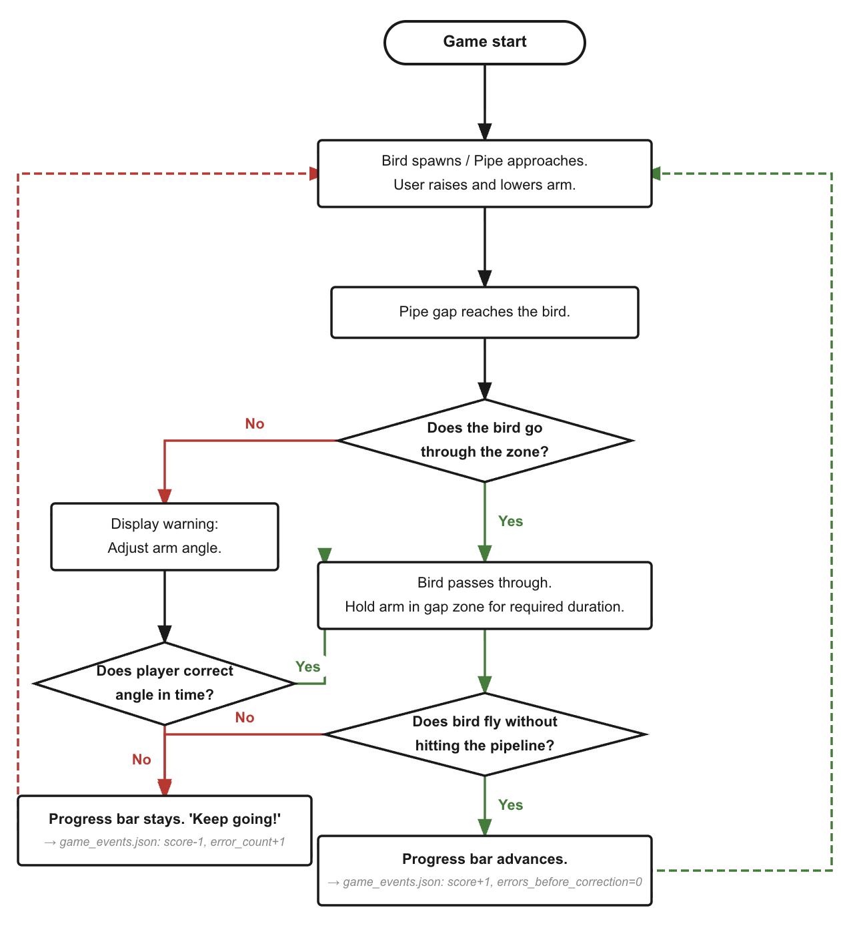

Rock climbing:
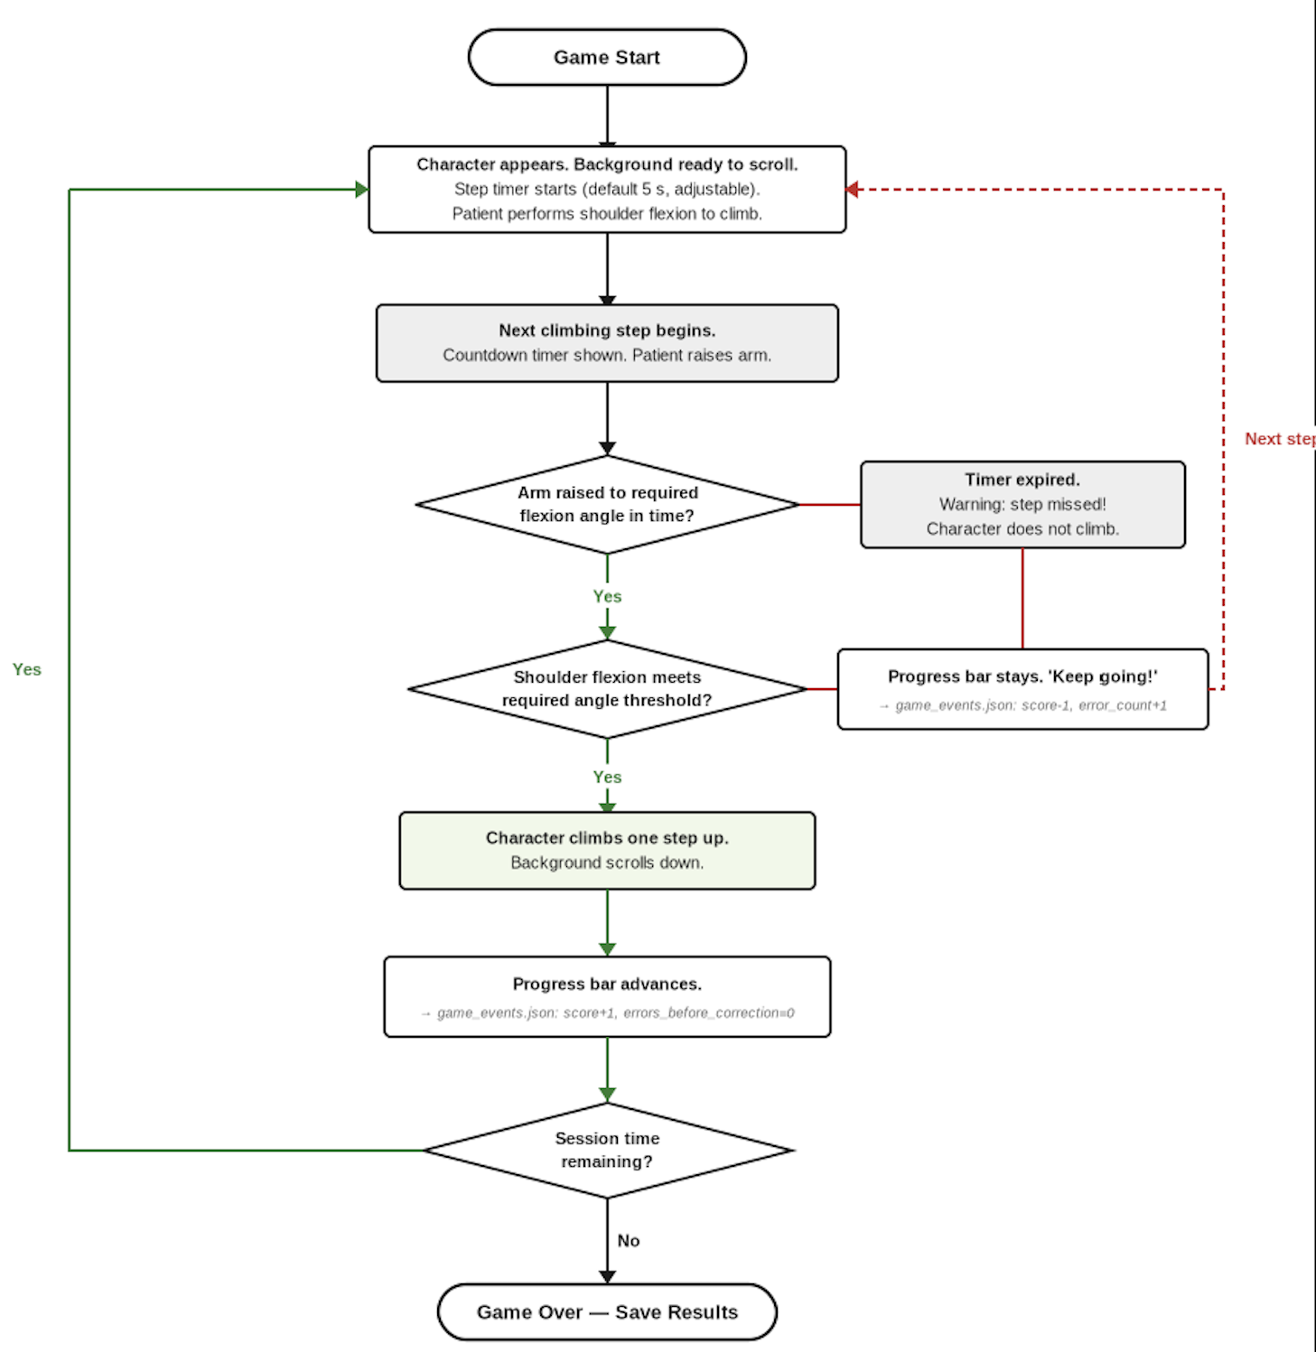

Whack-a-mole:
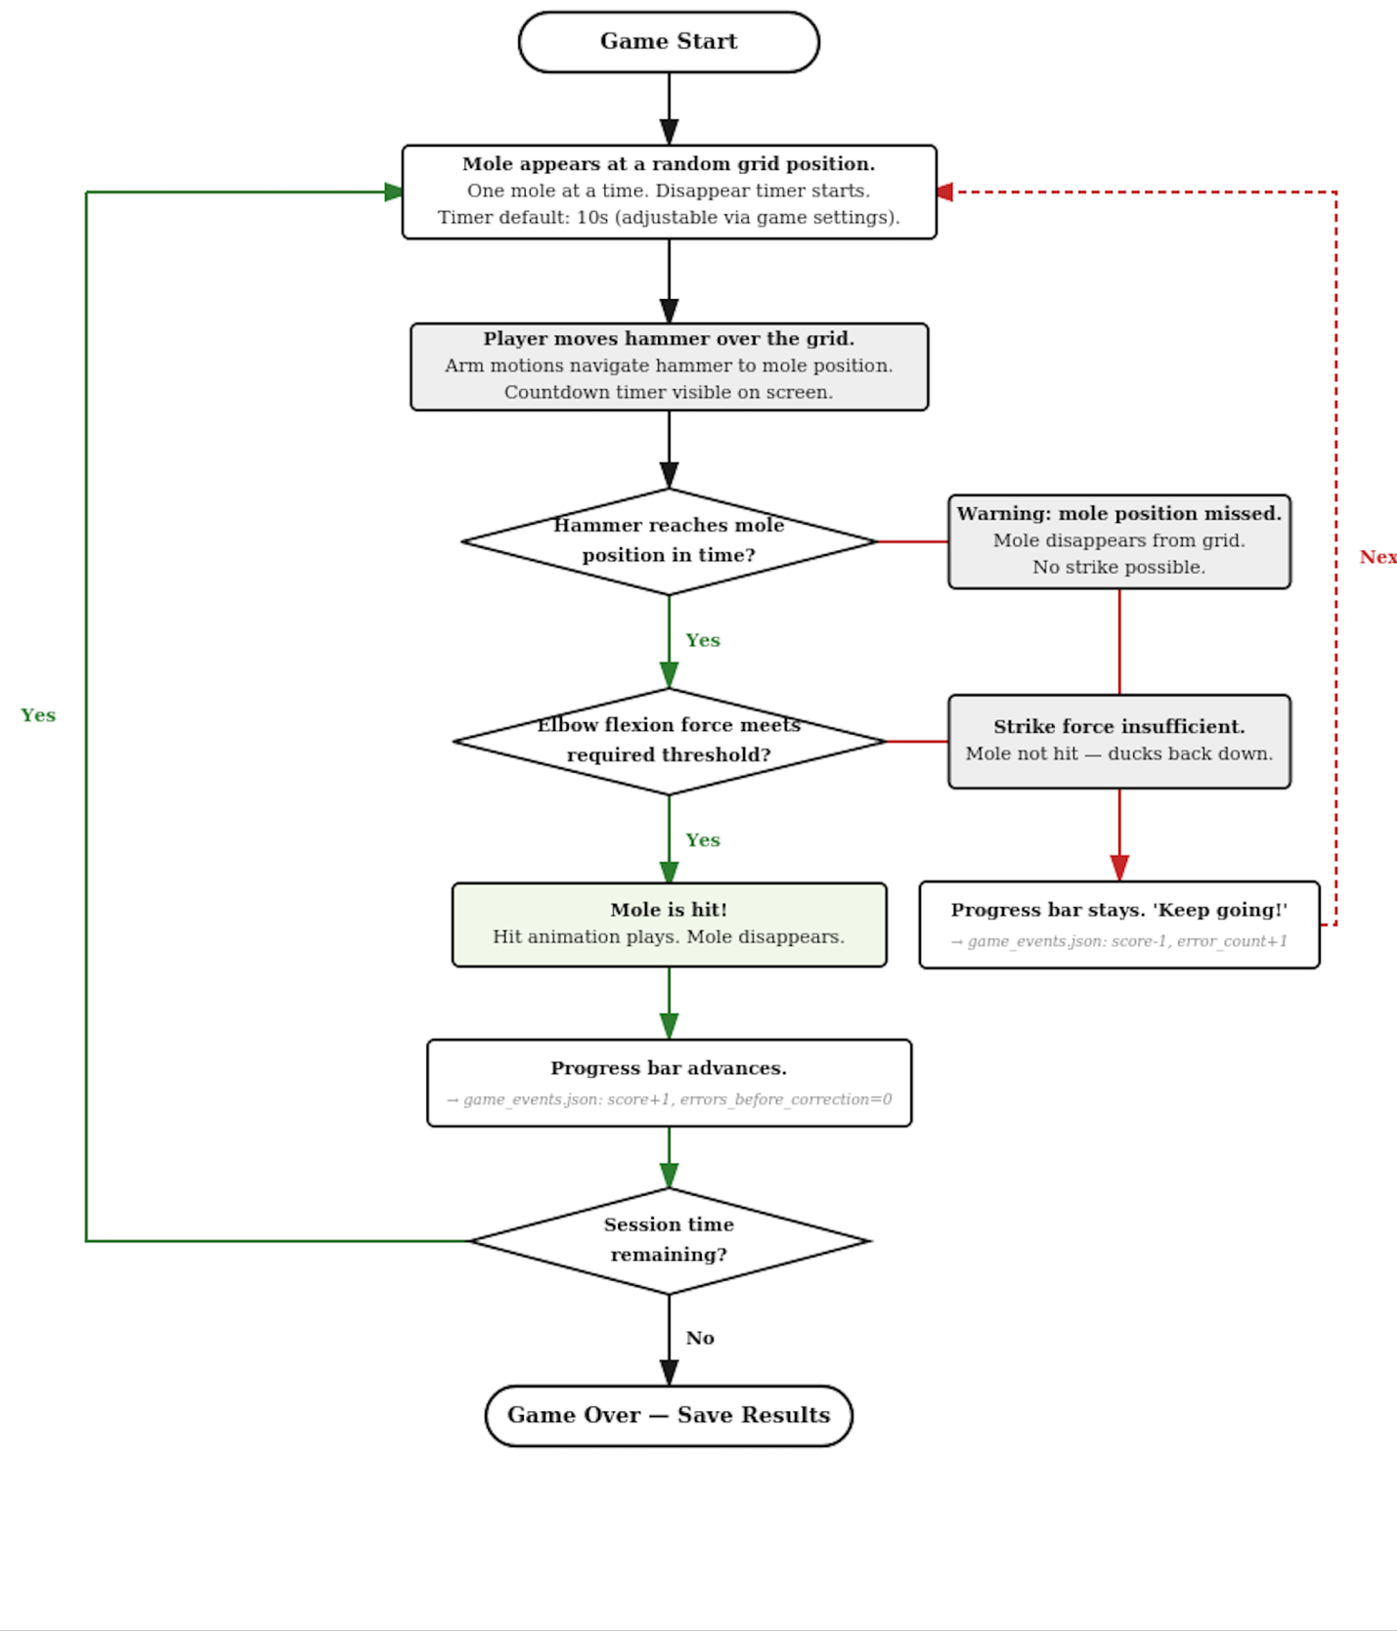

Steering Wheel :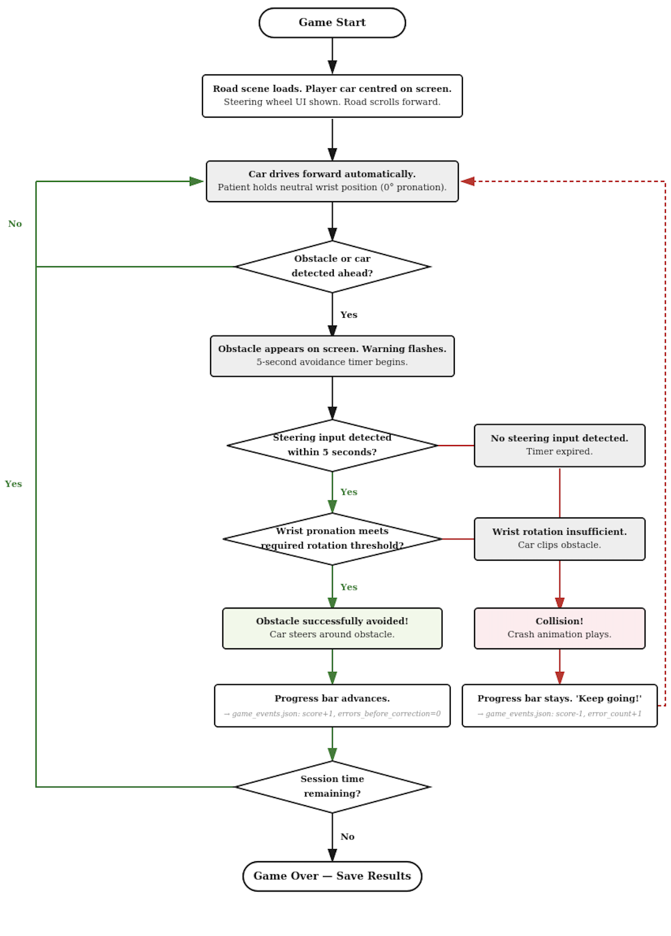

11. JSON File Architecture for calibration

User data is organized into three JSON files per user, separated by mutability. Each file has a defined owner, updated frequency and read/write policy. The ROM Calibration scene interacts with the two of these three files (reads one, writes one).

11.1 Folder structure
/data/users/{user_id}/
├── profile.json ← Identity, rarely changes
├── calibration.json ← Calibration data (ROM, IMU bias, correction factors)
└── preferences.json ← Session preferences, overwritten each session

11.2 Mutability categories

File | Category | Written by | Frequency
profile.json | Immutable (app-side) | Admin/clinician tooling only | Once, at account creation
calibration.json | Recalibration-mutable | Scenes 3, 4, 5 (calibration scenes) | Only when recalibration runs
preferences.json | Session-mutable | Scene 2 (preferences scene) | Once per session

12. profile.json

User identify file. Created once at account creation and never written to by Unity runtime afterwards. An external admin/clinician tool may edit this file (e.g., to correct spelling or update affected side after clinical reassessment), but the VR app itself treats it as read-only.

12.1 Write policy
- The Unity runtime must not write to profile.json under any circumstances
- If the file is missing or malformed on app start, the app routes the user to account creation or shows an error. It does not attempt to create or repair the file
- Admin tooling is a separate application outside this spec’s scope

12.2 Field reference

Field | Type | Allowed values | Notes
user_id | string | "u_" + zero-padded int | Unique per user; used for folder path
username | string | Free text | Display name, shown in UI
affected_side | string | "left" | "right" | "bilateral" | Which limb needs rehabilitation
dominant_hand | string | "left" | "right" | Pre-injury dominant hand
headset_mode | string | "seated" | "standing" | Default play posture
created_at | string | ISO 8601 UTC | Account creation timestamp

12.3 Usage by the ROM Calibration scene

The ROM Calibration scene reads profile.json once at scene load. Only one field is used:
- User_id: to locate the user’s calibration.json file

13. Calibration.json

Holds all calibration data for the user across three calibration scenes. The ROM calibration scene is the only owner of the rom_profile block and never modifies any other field in this file.

13.1 Write policy
- Only three calibration scenes (Scene 3,4,5) write to this file
- Each scene writes ONLY its own block. The ROM Calibration scene writes to rom_profile, it does not touch imu_bias or correction_factors
- Writes use a read-modify-write pattern to preserve blocks owned by other scenes
- If the file does not exist on write, create it with only the current scene’s block populated

13.2 rom_profile block per joint entry schema

Each of the 5 joints has an entry with the following fields:
Field | Type | Allowed values | Notes
min | float | null | Degrees | null only when complete is false and no previous value existed
max | float | null | Degrees | null only when complete is false and no previous value existed
complete | bool | true | false | false only when current AND all previous attempts failed
retries | int | 0–1 | Number of auto-retries used on the most recent attempt
recorded_at | string | ISO 8601 UTC | When the STORED min/max were measured (may be from a prior session)
source | string | "current_session" | "preserved_from_previous" | Provenance of the stored min/max
last_attempt_at | string | ISO 8601 UTC | Timestamp of the most recent calibration attempt, regardless of outcome
last_attempt_failed | bool | true | false | true if the most recent attempt failed; drives clinician warnings

We also have three possible states per joint entry:
- Successful calibration
- Attempt failed but previous value preserved
- No previous values, current attempt failed

13.3 Failure handling, preserve previous values

When a joint fails both calibration attempts, the behaviour depends on whether a previous successful values exist:
- If previous entry exists and was complete, preserve its min, max, recorded_at, and set source to “preserved_from_previous” , last_attempt_failed to true
- If no previous entry exists (first calibration, or previous was also incomplete), set min and max to null, complete to false
- In either case, append a failure entry to the session’s sensor_health.json

14. Preferences.json

Session-level preferences written by scene 2 once at the start of each session. The ROM calibration scene does not read or write this file.

14.1 Write policy
- Only scene 2 writes to this file
- The entire file is overwritten each time
- Other scenes read the file if they need session preferences

15. Manager architecture
The architecture is split into two layers: 13 core managers that live in the persistent core scene and orchestrate the entire app, and 5 per-mini game managers that exist within each mini-game scene.

Part 1 – Core Managers
These managers live in the persistent Core scene. They are instantiated at startup by AppManager and persist across all scene transitions via DontDestroyOnLoad.

1.NetworkManager
Responsibility | Listens on UDP port 5010, parses Pi packets, broadcasts to subscribers. No interpretation — purely a data pipeline.
Lifecycle | Singleton, started by AppManager, persists across scenes (DontDestroyOnLoad)
State | udpClient, isListening, packetsReceivedTotal, lastPacketTimestamp, lastPacketLatencyMs, isPiConnected
Public API | StartListening(), StopListening(), IsPiConnected(), GetStats()
Events emitted | OnPacketReceived(UdpPacket), OnConnectionLost(), OnConnectionRestored()
Depends on | None
Files | None

2. DataManager
Responsibility | All JSON file I/O. Loads/saves user files, validates schemas, atomic writes. No business logic.
Lifecycle | Singleton, instantiated by AppManager at startup
State | currentUserId, currentSessionId, userFolderPath, in-memory caches for profile/calibration/preferences
Public API | LoadProfile(), LoadCalibration(), SaveCalibration(), LoadPreferences(), SavePreferences(), AppendSensorHealth(), LoadAdaptationState(), SaveAdaptationState()
Events emitted | OnFileLoadFailed(filename, error), OnFileWriteFailed(filename, error)
Depends on | UserManager (for user_id)
Files | Reads & writes all JSON files

3.AudioManager
Responsibility | Plays all audio (instructions, countdown, feedback cues, game audio). Respects audio_on preference globally.
Lifecycle | Singleton, started by AppManager
State | isMuted, currentLanguage, audioClipCache, currentlyPlayingSource
Public API | PlayClip(clipKey), PlayInstruction(scene, joint), PlayCountdownNumber(n), PlayFeedbackCue(type), Stop(), SetMuted(bool)
Events emitted | OnClipFinished(clipKey)
Depends on | DataManager (read preferences for audio_on), UserManager (for language)
Files | None (audio assets in Unity Resources, not JSON)

4.CompensationDetector
Responsibility | Subscribes to NetworkManager packets, applies detection rules, emits compensation events when thresholds crossed. Rate-limits same-event-type to avoid spam.
Lifecycle | Singleton, started by SessionManager at game start, paused outside games
State | isActive, userROMProfile, lastEventByType, rateLimitWindowMs, detectionRules
Public API | Activate(), Deactivate(), LoadUserProfile(rom), GetCompensationCounts()
Events emitted | OnCompensationDetected(type, joint, severity, angle), OnPostureRestored()
Depends on | NetworkManager (subscribes to packets), DataManager (loads ROM profile)
Files | Reads calibration.json (ROM profile only)

5. SensorHealthMonitor
Responsibility | Tracks UDP dropouts, latency spikes, packet loss. Logs to sensor_health.json. Flags session data quality.
Lifecycle | Singleton, started by AppManager
State | dropoutEvents, latencyEvents, currentSessionQuality, latencyThresholdMs, dropoutThresholdMs
Public API | LogEvent(type, details), GetCurrentSessionQuality(), GetEventCount(type)
Events emitted | OnDataQualityDegraded(reason)
Depends on | NetworkManager (monitors packet stream), DataManager (writes log)
Files | Writes sessions/{id}/sensor_health.json

6.UserManager
Responsibility | Owns the active user session. Handles user selection at app start, exposes currentUserId and profile data to other managers. Read-only against profile.json.
Lifecycle | Singleton, started by AppManager after DataManager is ready
State | currentUserId, currentUserProfile, availableUsers, isLoggedIn
Public API | SelectUser(userId), GetCurrentProfile(), GetAffectedSide(), GetLanguage(), Logout(), ListAvailableUsers()
Events emitted | OnUserSelected(userId), OnUserLoggedOut()
Depends on | DataManager (loads profile.json)
Files | Reads profile.json (never writes)

7.CalibrationManager
Responsibility | Orchestrates the 3 calibration scenes (IMU bias, ROM, functional). Decides which need to run. Owns recording logic, retry logic, validation. Hands results to DataManager.
Lifecycle | Singleton, activated by SessionManager when entering a calibration scene
State | currentScene, currentJoint, currentPhase, runningMin, runningMax, retryCount, imuBiasResults, romResults, correctionResults
Public API | StartImuBiasCalibration(), StartRomCalibration(), StartFunctionalCalibration(), IsCalibrationRequired(), GetCurrentRomProfile()
Events emitted | OnCalibrationStarted(type), OnJointTestStarted(joint), OnJointTestCompleted(joint, entry), OnCalibrationCompleted(type), OnCalibrationFailed(type, reason)
Depends on | NetworkManager, AudioManager, DataManager, UserManager
Files | Reads & writes calibration.json

8.SessionManager
Responsibility | Orchestrates the entire session flow. Decides which scene loads next based on session state, calibration status, and user choices. Manages session_id and session timing.
Lifecycle | Singleton, started by AppManager after user login
State | currentSessionId, sessionStartedAt, sessionConfig, gameSchedule, currentSceneIndex, sessionState (Setup/Playing/Questionnaire/Complete)
Public API | StartNewSession(), EndSession(), AdvanceToNextScene(), GetSessionConfig(), GetElapsedSessionTime(), PauseSession(), ResumeSession()
Events emitted | OnSessionStarted(sessionId), OnSceneTransition(from, to), OnSessionEnded(summary), OnSessionPaused()
Depends on | UserManager, CalibrationManager, GameManager, DataManager, AdaptationManager
Files | Writes sessions/{id}/config.json

9.AppManager
Responsibility | Top-level lifecycle. Boots all other managers in correct order at app start. Handles graceful shutdown, app pause/resume (Quest passthrough, headset off).
Lifecycle | Singleton, the very first script to run (RuntimeInitializeOnLoadMethod)
State | appState (Booting/Ready/Running/ShuttingDown), bootSequenceComplete, bootErrors[]
Public API | BootSequence(), Shutdown(), OnApplicationPause(), OnApplicationQuit(), GetAppState()
Events emitted | OnBootComplete(), OnBootFailed(errors), OnAppPaused(), OnAppResumed(), OnAppShuttingDown()
Depends on | None (boots everyone else)
Files | None directly

10. AdaptionManager
Responsibility | Owns difficulty adaptation across sessions. Reads previous performance, decides next session's difficulty per game, updates rolling averages, computes session-over-session deltas.
Lifecycle | Singleton, started by AppManager. Active throughout session.
State | currentAdaptationState, rollingScoreWindow, difficultyAdjustmentRules, pendingUpdates
Public API | GetDifficultyForGame(gameName), RecordGameResult(gameName, score, completed), ComputeSessionDelta(), GetROMTrend(joint, lookbackSessions)
Events emitted | OnDifficultyAdjusted(gameName, oldLevel, newLevel), OnAdaptationStateUpdated()
Depends on | DataManager (load/save adaptation_state.json), GameManager (game results)
Files | Reads & writes adaptation_state.json

11.GameManager
Responsibility | Loads/unloads mini-game scenes (additive). Manages game lifecycle within a session. Aggregates per-game results. Hands game scores to AdaptationManager and DataManager.
Lifecycle | Singleton, used during the gameplay portion of a session
State | currentGameName, gameSceneHandle, currentGameStartTime, currentGameResults, completedGames[]
Public API | LoadGame(gameName, difficulty), UnloadCurrentGame(), EndCurrentGame(score, completed), GetCurrentGameTime(), GetGamesCompleted()
Events emitted | OnGameLoaded(gameName), OnGameStarted(gameName), OnGameEnded(gameName, results), OnGameUnloaded(gameName)
Depends on | SessionManager, AdaptationManager, DataManager, CompensationDetector
Files | Writes sessions/{id}/games.json (appends per game)

12. FeedbackManager
Responsibility | Receives compensation events, decides which feedback channels to fire (text/audio/avatar/haptic), respects user preferences and 5s rate limit. Logs feedback events to events.json.
Lifecycle | Singleton, active only during gameplay
State | lastFeedbackTimestamp, feedbackPrefs, severityColorMap, eventQueue
Public API | Activate(), Deactivate(), OnCompensationReceived(event), SetFeedbackChannel(channel, enabled)
Events emitted | OnFeedbackFired(channel, type, latencyMs)
Depends on | CompensationDetector (subscribes), AudioManager (audio cues), DataManager (writes events)
Files | Appends to sessions/{id}/events.json

13. QuestionnaireManager
Responsibility | Runs post-game questionnaire UI flow. Loads question content, displays Likert panels via Meta Interaction SDK, captures responses, hands data to DataManager.
Lifecycle | Singleton, activated by GameManager after each game ends
State | currentQuestions[], currentResponseIndex, responses{}, currentGameContext
Public API | StartQuestionnaire(gameName), SubmitResponse(questionId, value), IsActive(), GetCurrentQuestion()
Events emitted | OnQuestionnaireStarted(gameName), OnResponseSubmitted(qId, value), OnQuestionnaireCompleted(responses)
Depends on | GameManager (game context), DataManager (writes responses), AudioManager (optional audio prompts)
Files | Writes responses into sessions/{id}/games.json (questionnaire block)

Part 2 – Per-Game Manager Pattern
Every mini-game implements 5 managers following the pattern below. Replace {Game} with the game name. These managers are instantiated by GameManager when the game scene loads and destroyed when it unloads.

1.{Game}Controller
Responsibility | Game-specific state machine: start, playing, paused, ended. Owns score, lives/health, difficulty. Decides win/lose. Hands final results to GameManager.
Lifecycle | Instantiated by GameManager when game scene loads, destroyed on unload
State | gameState, currentScore, currentDifficulty, lives, gameStartTime, runningMaxAngle, runningMinAngle
Public API | StartGame(difficulty), PauseGame(), ResumeGame(), EndGame(reason), GetCurrentScore()
Events emitted | OnScoreChanged(value), OnGameOver(reason, finalScore), OnLifeLost()
Depends on | {Game}InputAdapter, {Game}ObjectSpawner, {Game}UIManager, GameManager (parent)
Files | None (results passed up to GameManager)

2. {Game}UIManager
Responsibility | Game-specific HUD only (score display, in-game timer, game-specific buttons, win/lose screens). Does NOT handle global UI like settings.
Lifecycle | Instantiated with game scene, destroyed on unload
State | scoreText, timerText, gameOverPanel, pauseButton, currentDisplayedScore
Public API | UpdateScore(value), UpdateTimer(seconds), ShowGameOver(score, message), ShowPauseMenu(), Hide()
Events emitted | OnPauseButtonPressed(), OnRestartPressed(), OnExitPressed()
Depends on | {Game}Controller (subscribes to score events)
Files | None

3. {Game}ObjectSpawner
Responsibility | Spawns/despawns game objects (pipes, moles, climbing holds, obstacles). Owns object pool for performance. Adjusts spawn rate by difficulty.
Lifecycle | Instantiated with game scene
State | objectPool, spawnInterval, currentSpawnRate, activeObjects[], spawnTimer
Public API | StartSpawning(difficulty), StopSpawning(), SpawnObject(type, position), DespawnObject(obj), ClearAll()
Events emitted | OnObjectSpawned(obj), OnObjectHit(obj), OnObjectMissed(obj)
Depends on | {Game}Controller (reads difficulty), GameManager (game state)
Files | None

4. {Game}InputAdapter
Responsibility | Subscribes to NetworkManager packets, translates joint angles into game-specific actions ('arm above 60° → bird up', 'wrist rotation → steering wheel angle'). Each game defines its own mapping.
Lifecycle | Instantiated with game scene
State | targetJoint, angleThresholds, currentMappedValue, inputSmoothingWindow
Public API | Activate(), Deactivate(), SetTargetJoint(joint), GetCurrentInputValue()
Events emitted | OnInputAction(actionType, value)
Depends on | NetworkManager (subscribes to packets)
Files | None

5.{Game}SceneSetup
Responsibility | Sets up the game environment when the game scene loads (camera placement, lighting, skybox, ambient props, background music). Tears it all down on unload. Each game has its own visual style (Flappy Bird sky vs. rock face vs. arcade cabinet for Whac-A-Mole).
Lifecycle | Instantiated with game scene by GameManager, destroyed on unload
State | cameraRig, lightingPreset, skyboxMaterial, ambientAudioSource, environmentRoot
Public API | Setup(), Teardown(), GetCameraRig(), SetLightingMode(mode)
Events emitted | OnSceneSetupComplete(), OnSceneTeardownComplete()
Depends on | AudioManager (for ambient music), GameManager (for game lifecycle)
Files | None

Part 3- Boot order

AppManager is responsible for booting all other managers in the correct order:

- AppManager (self)
- DataManager – needed by everyone for file I/O
- UserManager – depends on DataManager, needed by next layer
- NetworkManager – independent, can boot in parallel
- AudioManager – depends on DataManager( preferences)
- SensorHealthMonitor – depends on NetworkManager, DataManager
- AdaptionManager – depends on DataManager
- CalibrationManager, SessionManager, GameManager, FeedbackManager, CompensationManager, QuestionnaireryManager – depend on multiple of the above; can boot in parallel after step 7.

12 Adaptive Difficulty Algorithm (IGNORE FOR NOW)
// Computed at the end of each exercise (ExerciseController) float successRate = reps_completed / (float)reps_attempted; float compRate = compensation_event_count / (float)reps_completed; float fatigueIndex = last30pct_mean / first30pct_mean; string recommendation; if (successRate >= 0.85f && compRate < 0.15f && fatigueIndex > 0.85f) recommendation = "AUTO_INCREASE"; else if (successRate < 0.60f || compRate > 0.40f || fatigueIndex < 0.70f) recommendation = "AUTO_DECREASE"; else recommendation = "MAINTAIN";

The difficulty_recommendation is logged and shown in the clinician portal. It is NOT applied automatically without clinician review in the current protocol.

Parameter | Easier | Default | Harder
Target ROM % of patient max | 50% | 70% | 90%
Required hold duration (s) | 3 s | 5 s | 8 s
Rep count | 6 | 10 | 15
Rest time between sets | 30 s | 20 s | 10 s
Compensation tolerance | Moderate | Mild | Strict

